***DIY Clock 360 . Wall Clock***

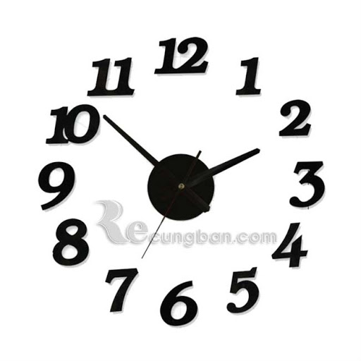

*The Diy Clock 360 wall clock has a diameter of 40 cm. Black. Quazt machine, uses AA batteries. The product is packaged and comes with detailed installation instructions. Diy wall clock brings a new and unique feature to your home. Suitable as a housewarming gift or a wedding gift,*